A La Cart Application Form

1. Payment Procedure
2. Please FILL UP the application form.
3. SCAN AND SEND back the application together with your XEROX copy of your valid id - back to back.
4. Pay the amount of package that you want to avail through BANK.

**BANCO DE ORO ACCOUNT:**ACCOUNT NAME: Joseph Abrera (Ateam Admin)  
ACCOUNT NUMBER: 7090067944

**BPI ACCOUNT:**ACCOUNT NAME: ATQ TRADING (Christopher Cheng)  
ACCOUNT NUMBER: 5575057383

1. After the payment has been made, attach the deposit slip into a bond paper and please write:   
   ATTENTION TO:   
   **Joseph Abrera and   
   YOUR FULL NAME and   
   PACKAGE THAT YOU AVAILED and   
   THE CONCEPT.**
2. SCAN AND SEND TO:_______________________ for confirmation  
    Once you've done this maam/sir, please text me at ________________so I will be able to process your application and your contract as soon as possible.
3. Placing of Repeat Orders
4. Orders can be made through text, call or email.
5. Product orders should be made based on suggested packs or containers and not by piece.
6. Delivery of Products
7. Within Greater Manila Area: Free Delivery at a minimum of P5,000 worth of Products.
8. Zoning
9. Food outlets should be 1 kilometer away from each other.
10. Shelf Life of Products
11. 2 weeks products as long as kept frozen.
12. 4 weeks for other products as long as kept frozen.
13. Once defrosted, products must be consumed within 24 hours, not advisable to refrost.
14. Documents
15. All documents needed for food cart application can be made available upon request. Namely (a) letter of intent, (b) product menu, (c) food cart picture
16. Contract
17. Product dealership is lifetime provided that you have to renew your contract every (3) years for the minimal cost of the notary fee only
18. Optional Cart Upgrades:
19. Optional/Additional cart upgrade:

* Ateam Logo or Alacart Logo Acrylic Cutout instead of normal vinyl at the bottom of the cart : Add P2,000 to total cart price
* Sintra Board Menu instead of normal tarpaulin : Add P1,000 to total cart price

**PRODUCT PRICES ON PACKS/CONTAINERS (as of May 2018)**

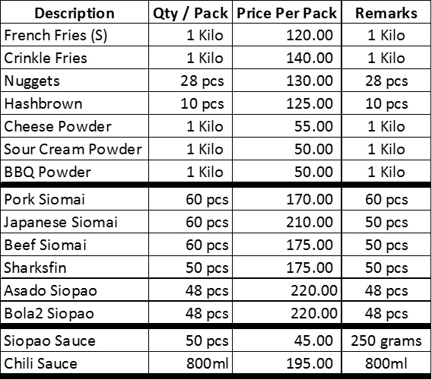



**3 IN 1 CART EQUIPMENTS**

|  |  |
| --- | --- |
| ***FRIES + DIMSUM + LEMON JUICE CART*** | |
| **Description** | **Quantity** |
| Fryer (GAS DUAL TUB) | 1 |
| Plastic Container Rectangle (For Shaking) | 3 |
| Plastic Container Round (For powder) | 3 |
| Weighing Scale | 1 |
| Tong | 1 |
| Strainer | 1 |
| TBSP set | 1 |
| Tissue Holder | 1 |
| Steel Bowl | 2 |
| Large Glass Display Steamer | 1 |
| Squeeze Bottle | 2 |
| Plastic Container Rectangle (For Keeping) | 6 |
| Plastic Container Round (For Sauces) | 6 |
| Ice Box | 1 |
| Fruit Juice Extractor | 1 |
| Shaker | 1 |
| Jigger | 1 |
| Stirrer | 1 |

**3 IN 1 CART EQUIPMENTS (FRAPPE)**

|  |  |
| --- | --- |
| ***FRIES + DIMSUM + FRAPPE*** | |
| **Description** | **Quantity** |
| Fryer (GAS DUAL TUB) | 1 |
| Plastic Container Rectangle (For Shaking) | 3 |
| Plastic Container Round (For powder) | 3 |
| Weighing Scale | 1 |
| Tong | 1 |
| Strainer | 1 |
| TBSP set | 1 |
| Tissue Holder | 1 |
| Steel Bowl | 2 |
| Large Glass Display Steamer | 1 |
| Squeeze Bottle | 2 |
| Plastic Container Rectangle (For Keeping) | 3 |
| Plastic Container Round (For Sauces) | 3 |
| Ice Box | 1 |
| Industrial Blender | 1 |
| Heavy Duty Whipper | 1 |
| Powder Container | 1 |
| Syrup Container | 1 |
| Jigger | 1 |
| Powder Scooper | 1 |
| Ice Scooper | 1 |

**2 IN 1 CART EQUIPMENTS (FRIES & LEMON CART)**

|  |  |
| --- | --- |
| ***FRIES + LEMON CART*** | |
| **Description** | **Quantity** |
| Fryer (GAS DUAL TUB) | 1 |
| Plastic Container Rectangle (For Shaking) | 3 |
| Plastic Container Round (For powder) | 3 |
| Weighing Scale | 1 |
| Tong | 1 |
| Strainer | 1 |
| TBSP set | 1 |
| Tissue Holder | 1 |
| Steel Bowl | 2 |
| Ice Box | 1 |
| Fruit Juice Extractor | 1 |
| Shaker | 1 |
| Jigger | 1 |
| Stirrer | 1 |

**2 IN 1 CART EQUIPMENTS (DIMSUM & LEMON CART)**

|  |  |
| --- | --- |
| ***DIMSUM + LEMON CART*** | |
| **Description** | **Quantity** |
| Large Glass Display Steamer | 1 |
| Tong | 1 |
| TBSP set | 1 |
| Squeeze Bottle | 2 |
| Tissue Holder | 1 |
| Plastic Container Rectangle (For Keeping) | 3 |
| Plastic Container Round (For Sauces) | 3 |
| Ice Box | 1 |
| Fruit Juice Extractor | 1 |
| Shaker | 1 |
| Jigger | 1 |
| Stirrer | 1 |

**2 IN 1 CART EQUIPMENTS (DIMSUM & FRAPPE)**

|  |  |
| --- | --- |
| ***DIMSUM + FRAPPE CART*** | |
| **Description** | **Quantity** |
| Large Glass Display Steamer | 1 |
| Tong | 1 |
| TBSP set | 1 |
| Squeeze Bottle | 2 |
| Tissue Holder | 1 |
| Plastic Container Rectangle (For Keeping) | 3 |
| Plastic Container Round (For Sauces) | 3 |
| Ice Chest | 1 |
| Industrial Blender | 1 |
| Heavy Duty Whipper | 1 |
| Powder Container | 1 |
| Syrup Container | 1 |
| Jigger | 1 |
| Powder Scooper | 1 |
| Ice Scooper | 1 |

**2 IN 1 CART EQUIPMENTS (FRIES & FRAPPE CART)**

|  |  |
| --- | --- |
| ***FRIES + FRAPPE*** | |
| **Description** | **Quantity** |
| Fryer (GAS DUAL TUB) | 1 |
| Plastic Container Rectangle (For Shaking) | 3 |
| Plastic Container Round (For powder) | 3 |
| Weighing Scale | 1 |
| Tong | 1 |
| Strainer | 1 |
| TBSP set | 1 |
| Tissue Holder | 1 |
| Steel Bowl | 2 |
| Ice Chest | 1 |
| Industrial Blender | 1 |
| Heavy Duty Whipper | 1 |
| Powder Container | 1 |
| Syrup Container | 1 |
| Jigger | 1 |
| Powder Scooper | 1 |
| Ice Scooper | 1 |

**PROFITABILITY STUDY**

|  |  |  |  |
| --- | --- | --- | --- |
|  | LOW | MEDIUM | HIGH |
| Projected Daily Sales | P3,000 | P4,000 | P6,000 |
| Multiply by 30 days | 30 | 30 | 30 |
| Monthly Gross Sales | P90,000 | P120,000 | P180,000 |
| Average Mark-Up | 40% | 40% | 40% |
| Gross Profit | P36,000 | P48,000 | P72,000 |
| Operating Expenses |  |  |  |
| Rental | 4,000 | 4,000 | 4,000 |
| Labor | 10,000 | 10,000 | 10,000 |
| Utilities | 800 | 1,500 | 2,000 |
| Misc. | 700 | 1,000 | 1,500 |
| Total Operating Expenses | P15,500 | P16,500 | P17,500 |
| NET PROFIT | P20,500/month | P31,500 | P54,500 |

**FOOD MARGIN and MARK-UP PERCENTAGE**